- Explain the revenue breakdown by year and by-product. Evaluate how different products contribute to annual revenue and come up with suggestions to increase the sales of the low-selling items.

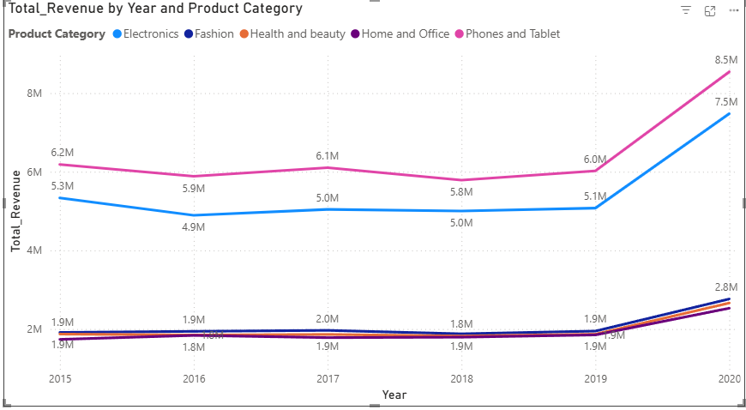

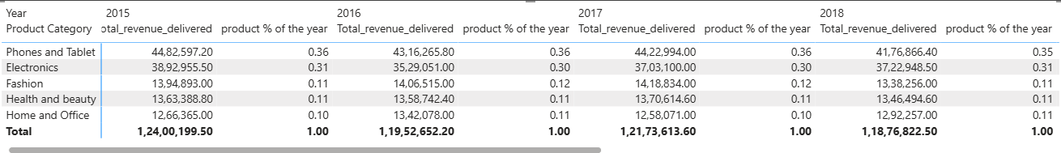

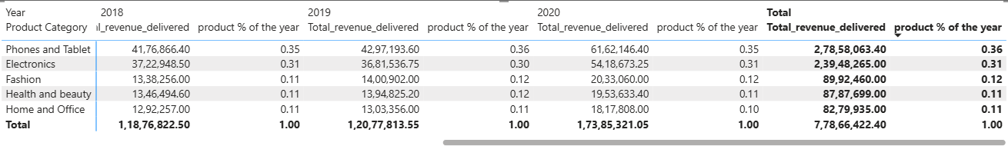

Revenue was fairly stable from 2015-2019 , however due to COVID-19 Pandemic , people had a rush to buy more supplies and goods , therefore there seems to be a boost in sales across the board . However the relative sales of product categories remained same.

The revenue analysis by year and product category clearly shows us that Phones & Tablets with 36% contribution to total revenue and Electronics with 31% contribution dominate the chart . together contributing almost two-thirds of annual revenue. Categories such as Fashion (12%), Health & Beauty (11%), and Home & Office (10%) consistently underperform, contributing much smaller shares.

While all categories experienced a boost in 2020 ,perhaps due to people just coming out of COVID-19 pandemic ,but still the relative proportions of % contribution remained the same, indicating stable but uneven distribution.

Suggestions to Increase Low-Selling Items:

- Cross-Selling & Bundling: Bundle low-selling items (e.g., accessories, home products) with bestsellers such as phones or electronics.
- Targeted Promotions: Seasonal campaigns and discount offers for Fashion, Health & Beauty, and Home & Office.
- Visibility: Highlight these categories on homepages, recommendation feeds, and ads.
- Product Improvement: Improve presentation, reviews, and descriptions for better conversion.
- Product Strategy: Evaluate very low-performing SKUs for replacement with trending products.

Conclusion:
Revenue is heavily concentrated in Phones & Tablets and Electronics. Strategic promotions, bundling, and better positioning of weaker categories can balance sales and enhance overall growth.

- How many products were returned? Use a DAX function to get this metric. Examine the possible reasons for returns and consider how this metric could indicate improvements in product descriptions or quality control.

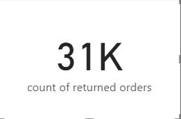
Dax :-

count of returned orders = CALCULATE(COUNT(Orders[Reason]),Orders[Status]="Returned")

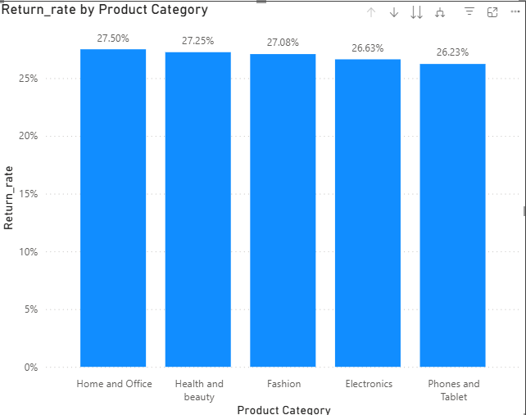
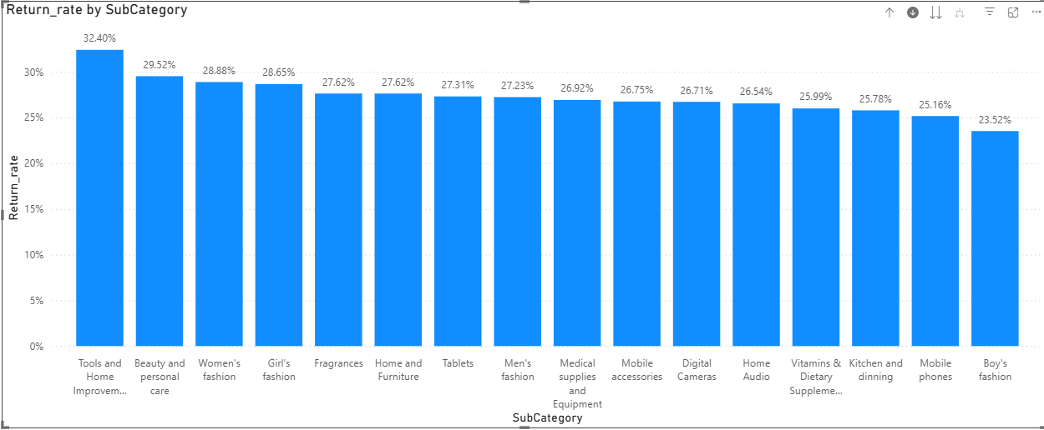

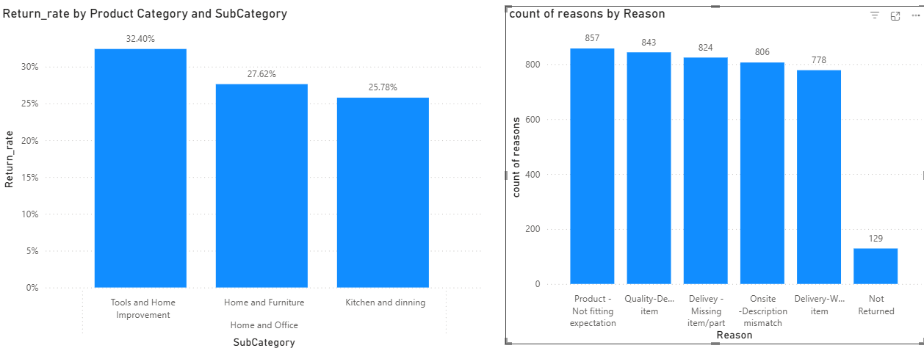

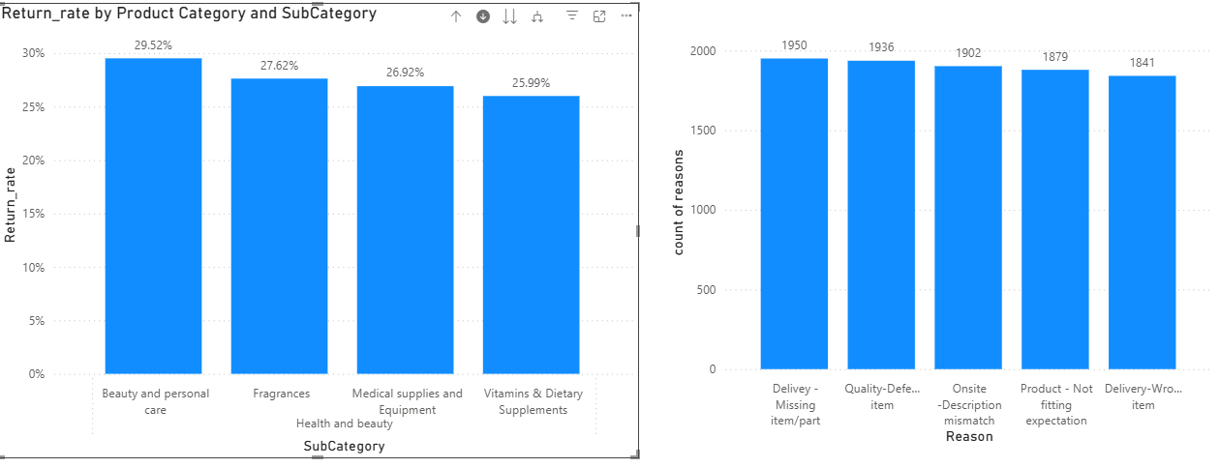

Interpretation : -

Many returns are concentrated in a few discretionary subcategories (Tools & Home Improvement, Home & Furniture, Fashion, Beauty) and are driven mainly by expectation mismatch, quality defects, and delivery/parts issues.

- Product not fitting expectation.
- Quality defects – Items were faulty or below acceptable quality.
- Delivery issues (wrong item, missing item/parts) – might be errors in picking, packing, or shipping.
- Onsite description mismatch – Product information (size, color, features) didn’t match what was received.

High return rates in Fashion and Home & Office link directly to description mismatch and size/fit issues.

Improvements:-

- Add detailed specifications, multiple product images, and clear size charts.
- Use “real-life photos” or videos to set accurate expectations.
- Add “What’s in the box” checklists to avoid surprises.

Beauty & Personal Care and Electronics categories show returns due to quality defects.

Improvements:-
- Introduce stricter vendor QC checks before products go live.
- Implement pre-shipment inspections to catch defective units.
- Track defect rates by supplier and hold vendors accountable.

Returns due to wrong items or missing parts point to warehouse and packing process gaps also can use following improvements

Improvements:-

- If “not fitting expectation” is common → the product page needs fixing.
- If “quality defect” is common → the supply chain and QC process need fixing.
- If “wrong item/missing parts” is common → the logistics and warehouse process need fixing

Analysis reveals that 31,000 orders were returned, with the leading causes being products not fitting expectations, quality defects, missing or wrong items, and mismatched descriptions. These returns points out systemic gaps: product pages often lack clear detail, vendor quality checks are insufficient, and logistics processes are prone to error. Addressing these issues will require clearer product descriptions with accurate visuals and sizing information, stronger quality control checks at the supplier and warehouse level, and stricter logistics protocols. By using return metrics as a feedback loop, the company can improve customer trust, reduce unnecessary costs, and strengthen overall product quality perception.

- Whenever a customer goes to Amazon, they’ll filter the most rated products to buy the better category. Can you verify this using any visualization or table that the ratings of products impact their sales value?

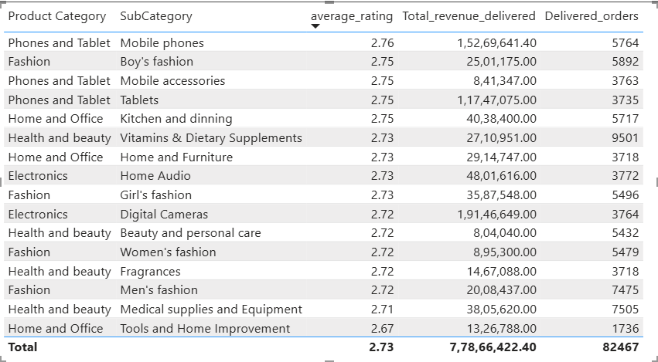

Interpretation : -

Overall Ratings Are Low
- The average rating across all subcategories is only 2.73 (out of 5).
- This suggests widespread dissatisfaction or unrealistic expectations → ratings may not strongly correlate with sales here.

High Revenue Despite Average Ratings

- Digital Cameras (Electronics) → Avg Rating 2.72, but ₹1.91 Cr revenue (highest in the table).
- Mobile Phones (Phones & Tablets) → Avg Rating 2.76, ₹1.52 Cr revenue (second highest).
- Both show that even with mediocre ratings, demand drives high sales in core categories.

Fashion Subcategories

- Boy’s Fashion (Rating 2.75) → ₹25 L revenue
- Girl’s Fashion (Rating 2.73) → ₹35 L revenue
- Men’s Fashion (Rating 2.72) → ₹20 L revenue
Despite similar ratings, revenues differ, suggesting demand and category preference matter more than rating.

Low Revenue, Low Ratings

- Beauty & Personal Care (2.72 rating, ₹8 L revenue) and Women’s Fashion (2.72 rating, ₹8.9 L revenue) → both categories struggle.
- Here, low ratings seem aligned with poor revenue, indicating customers avoid these products.

Delivered Orders vs Rating

- High orders in Vitamins & Dietary Supplements (9501 orders, 2.73 rating) show customers may prioritize necessity/price over rating.
- Tools & Home Improvement (Rating 2.67, lowest rating) has ₹13 L revenue and only 1,736 orders, showing low rating does hurt discretionary categories.

Key Insight

- Ratings have mixed impact:
  - In essential or high-demand categories (Phones, Cameras, Vitamins), sales remain strong even with mediocre ratings.
  - In discretionary categories (Fashion, Tools, Beauty), low ratings directly correlate with weaker sales and fewer orders.
This suggests customers use ratings as a stronger filter in lifestyle/discretionary items than in essential/electronics categories.

- Investigate how revenue distribution varies across different locations. Explore which geographical areas contribute most to sales and consider the strategic implications for regional marketing and distribution efforts. How might location-based trends inform the company's market segmentation and resource allocation approach?

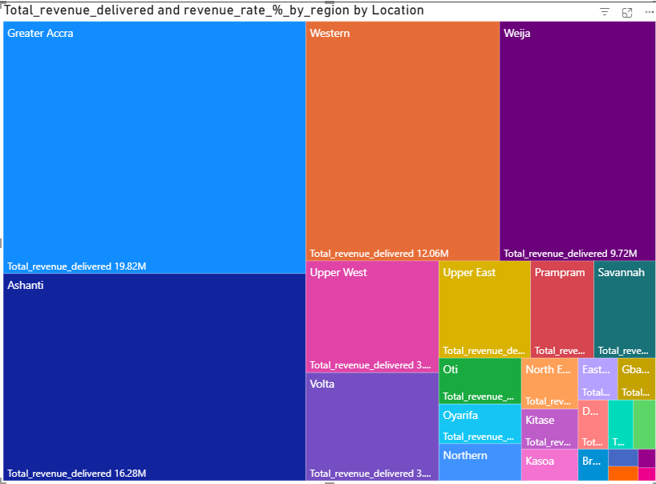
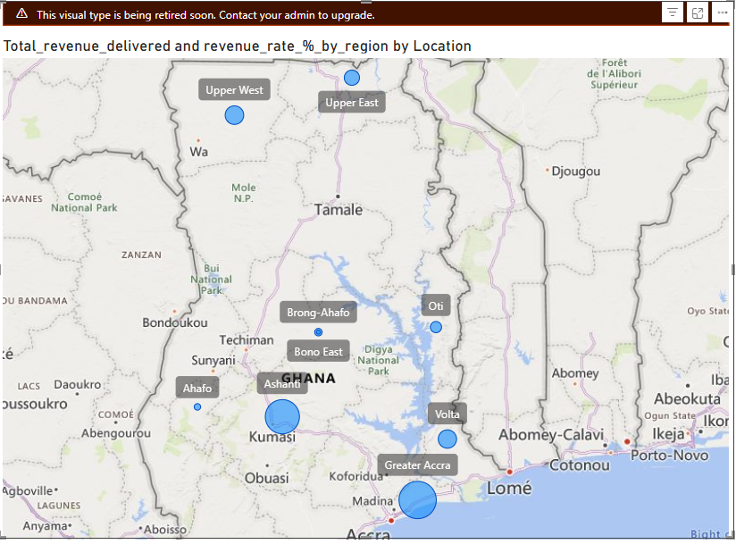
Regional Contribution

- Greater Accra → Highest revenue contributor (~₹19.82M).
  - Major commercial hub with high purchasing power and dense population.
  - Strong adoption of e-commerce.
- Ashanti Region → Second largest (~₹16.28M).
  - Another key market; represents a major consumer base.
- Western Region → Third (~₹12.06M).
  - Steady sales, showing good growth potential.
- Weija Sub-region → Notable contribution (~₹9.72M) despite being a smaller locality.
- Other regions (Upper West, Upper East, Volta, Oti, Northern, etc.)
  - Much smaller shares (~₹3–4M each or less).
  - Revenue heavily concentrated in a few urbanized locations.
Final Observation: Revenue distribution is highly skewed toward Greater Accra and Ashanti, which together make up almost half of total sales.

Strategic Implications for Marketing & Distribution

- Resource Allocation
  - Allocate higher marketing budgets and logistics capacity to Greater Accra, Ashanti, and Western, since they contribute the majority of revenue.
  - These areas should serve as primary distribution hubs.
- Regional Marketing Strategy
  - Urban hubs (Accra, Kumasi in Ashanti) → Promote premium products (Electronics, Smartphones, Fashion brands) since consumers here have higher disposable incomes.
  - Secondary regions (Volta, Upper East/West, Northern, Oti) → Focus on affordable and essential products (Home & Office, Health & Beauty).
- Customer Segmentation by Location
  - Segment customers into Urban High-Income vs Rural Value-Seeking.
  - Tailor offers like installment financing for premium items in Accra; discount bundles in smaller regions.
- Distribution & Logistics
  - Build/strengthen regional warehouses near Accra and Ashanti for faster deliveries.
  - For remote regions, introduce periodic bulk-shipping promotions (“Free Delivery Week” or minimum order free shipping).
- Growth Opportunities
  - Regions like Weija are already outperforming their size → invest in targeted marketing there (local influencer tie-ups, geo-targeted ads).
  - In smaller regions with low sales, test mobile promotions, regional fairs, or reseller partnerships.

The analysis shows that Greater Accra (₹19.82M) and Ashanti (₹16.28M) dominate revenue, followed by Western (₹12.06M). Together, these regions contribute nearly half of total sales, highlighting a strong concentration in urbanized, high-income areas. Smaller regions such as Volta, Upper East/West, and Oti contribute far less, indicating untapped potential.
Strategically, the company should prioritize marketing and logistics investments in Accra, Ashanti, and Western to maximize growth, while launching value-driven campaigns in emerging regions. By tailoring product mixes — premium offerings for urban centers and affordability bundles for smaller towns — the company can capture wider market share and improve overall revenue distribution.

- Determine which month could benefit from enhanced promotional offers to boost sales. Can you suggest some targeted marketing strategies here?

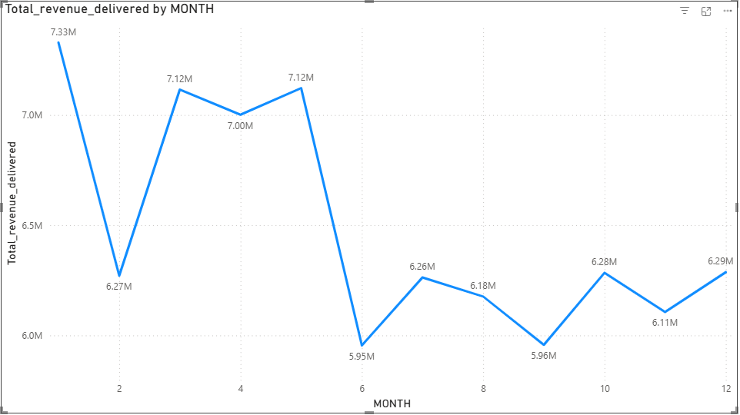
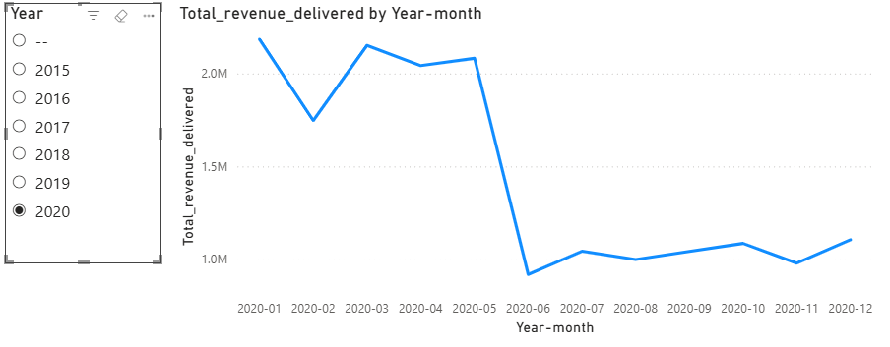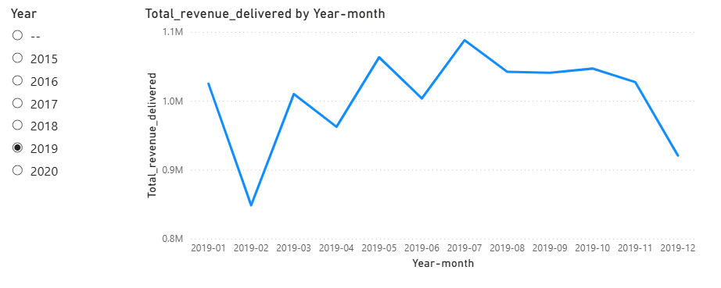

  - Strong Months: January, March, April, May (₹7.0M–7.3M range).
  - Weak Months: June (lowest at ₹5.95M), September (₹5.96M), and November (₹6.11M).
  - Overall Trend Shape: Peaks at start and Q2 → falls mid-year → struggles to recover fully toward year-end.

The monthly trend shows that January and March–May are the strongest sales periods, while June (₹5.95M) and September (₹5.96M) represent the lowest-performing months. This mid-year slump highlights the need for enhanced promotions, loyalty bonuses, and seasonal campaigns during June–September. Additionally, holiday sales in November–December underperform relative to January, suggesting untapped potential for stronger year-end promotions.

Targeted Promotional Strategies

- Mid-Year “Summer Boost” Campaign (June–August)
  - Run site-wide discounts (5–10%) or “Buy More, Save More” offers to counter seasonal slowdowns.
  - Double loyalty points for these months to encourage repeat buyers.
  - Bundle popular categories (e.g., Electronics + Accessories, Fashion + Footwear).
- Category-Focused Promotions
  - Push Fashion & Home and Office during June–August, as these are price-sensitive categories where discounts trigger faster volume growth.
  - Promote Electronics/Phones via financing (0% EMI, trade-in) instead of direct discounts to protect margins.
- Event-Driven Offers
  - Tie promotions to local festivals, back-to-school (July–August), or mid-year clearance.
  - Example: “Mid-Year Mega Sale – Refresh Your Home & Wardrobe” (Home & Office + Fashion).
- Customer Segment Targeting
  - Offer exclusive Gold/Platinum tier coupons during low-sales months to maintain momentum with loyal customers.
  - Send win-back offers (10–15% discount codes) to inactive customers who haven’t purchased in 3+ months.(there are no such customers here)
- Digital Engagement
  - Increase ad spend in low-performing months on social media and Google Shopping.
  - Use email + push campaigns with urgency (“48-hour flash sale”).

- Identify which products may require increased marketing efforts. Which items have high prices yet underperform in sales?

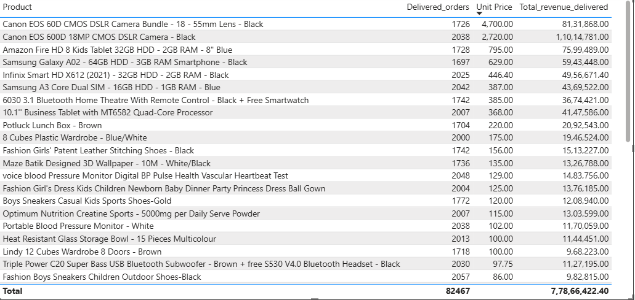

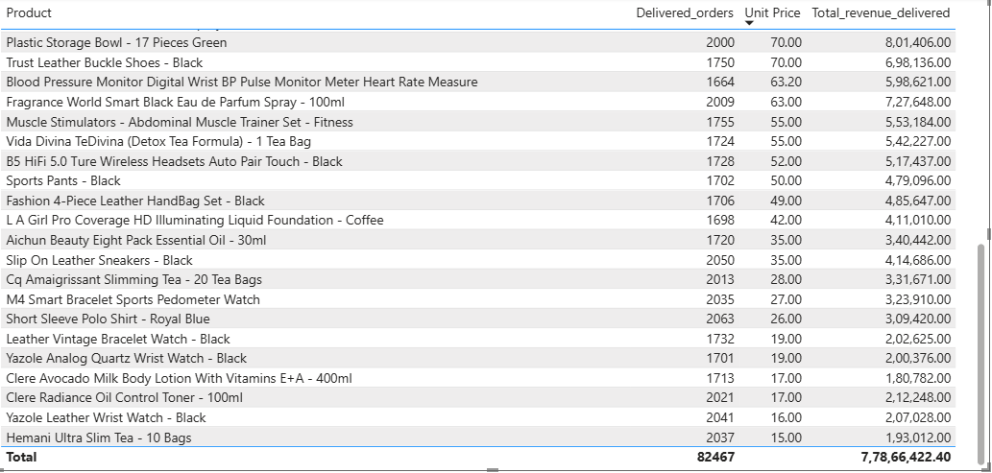

High-Price, Low-Sales Products
- Canon EOS 60D CMOS DSLR Camera Bundle – 18–55mm Lens (Electronics)
  - Unit Price: ₹4,700
  - Delivered Orders: 1,726 (low vs lower-priced categories).
  - Needs increased marketing & financing options like 0 EMI or exchange on old Camera for lower price.
- Canon EOS 600D 18MP CMOS DSLR Camera – Black (Electronics)
  - Unit Price: ₹2,720
  - Delivered Orders: 2,038
  - Premium DSLR with niche audience.
  - Underperforming relative to lower-cost phones.

- Samsung Galaxy A02 – 64GB, 3GB RAM Smartphone (Phones & Tablets)
  - Unit Price: ₹629
  - Delivered Orders: 1,697
  - Entry-level smartphone but struggles against cheaper alternatives.

Fashion Girls' Patent Leather Stitching Shoes – Black
- Unit Price ≈ ₹156, Delivered Orders ≈ 1,742, Avg Rating ≈ 2.7
- Issue: Low rating + high return rate for a fashion item.
- Marketing need: Customers are skeptical about quality/sizing. Improve with better product photography, sizing guides, influencer try-on campaigns, and satisfaction guarantees.

Fashion Girl’s Dress Kids Ball Gown / Boys Sneakers Casual Shoes
- Moderate price but weak repeat traction.
- Marketing need: Push via social media targeting parents, bundle discounts (“Buy 2 get 10% off”), and seasonal campaigns (festivals, back-to-school).

Health & Beauty
- Voice Blood Pressure Monitor / Portable Blood Pressure Monitor
  - Medical devices priced at ₹100–129, but suffer from high returns & average ratings.
  - Issue: Trust barrier for medical/health devices.
  - Marketing need: Partner with healthcare influencers/doctors, highlight accuracy/certifications, and offer extended warranty to reassure customers.

While premium cameras and smartphones remain obvious candidates for more marketing support, our analysis also shows Fashion, Home & Office, and Health & Beauty products struggling due to low ratings, high return rates, or weak perception of value.

- In Fashion, products like the Patent Leather Stitching Shoes and Kids’ Ball Gown Dresses need stronger visual marketing, influencer tie-ins, and clear size/quality guarantees to build trust.
- In Home & Office, items like the Plastic Wardrobes, Lunch Boxes, and 3D Wallpapers require better content marketing (how-to-assemble guides, durability videos) to overcome purchase hesitation.
- In Health & Beauty, medical devices such as Blood Pressure Monitors need trust-building campaigns, including endorsements, reviews, and assurance programs.

By broadening marketing efforts beyond just electronics, the company can balance growth across categories, reduce returns, and convert hesitant buyers into loyal repeat customers.

- Assess which products should have discounts. How can targeted incentives drive sales and customer loyalty for specific products?

products with moderate-to-high prices but weak sales include:

- Home & Office: Potluck Lunch Box (₹220, low volume), 8 Cubes Plastic Wardrobe (₹175, weak sales), Tools & Home Improvement (₹135, underperforming).
- Kitchen & Dining: Heat Resistant Glass Storage Bowl – 15 Pieces (₹100, slow mover).
- Fashion: Fashion Girls' Patent Leather Shoes (₹156, weak demand), Men’s Fashion Shoes (~₹120, low revenue).
- Electronics accessories: 6030 3.1 Bluetooth Home Theatre (₹385, modest revenue despite mid-price).

These items are priced higher than everyday low-value items, but they don’t have the brand strength of premium electronics like Canon EOS cameras or Amazon Fire tablets, which do not need discounting.

Recommendations

1. Apply time-limited discounts during low-sales months (June, September which are low sales months).
- Example: Potluck Lunch Box (₹220) and 6030 Bluetooth Home Theatre (₹385).
- Offer 15% off flash sale in June & September.
- Expected outcome: Boost demand during slow periods → lift sales of Potluck Lunch Box by ~20% and increase exposure of mid-range electronics like Home Theatre which may result in reducing stock stagnation.

2. Use bundled promotions — combining low sellers with bestsellers
- Example: Bundle 8 Cubes Plastic Wardrobe (₹175) with a Mobile Phone (e.g., Samsung A02 – ₹629).
- Example: Bundle Fashion Girls’ Shoes (₹156) with Boy’s Fashion (₹120) clothing items.
- Offer: Buy phone, get wardrobe at 30% off / Buy 2 fashion items, get 1 free.
- Expected outcome: Bundles increase visibility of slow sellers, improve AOV (average order value), and reduce unsold inventory.
- Customers perceive better value → higher satisfaction.

3. Offer loyalty-based discounts for repeat customers.
- Target products: Heat Resistant Glass Storage Bowl – 15 Pieces (₹100), Fashion Men’s Shoes (₹120).
- Offer: “5% off Kitchenware for your next purchase” OR “Repeat customers get ₹50 off Men’s Fashion.”
- Expected outcome: Encourages repeat purchases → estimated 10–15% uplift in second purchase rate. Builds loyalty by rewarding existing customers and reduces churn.

4. Run seasonal clearance campaigns for Fashion items with high returns or aging stock.
- Example: Fashion Girls’ Patent Leather Shoes (₹156, high returns), Women’s Fashion (₹120–₹125 range).
- Offer: “End of Season Clearance – Up to 25% off.”
- Expected outcome:
  - Clears aging stock quickly and reduce storage cost.
  - Attracts bargain hunters → can turn into repeat buyers.
  - Helps reduce return rate impact, since clearance pricing sets lower expectations.

- Come up with a loyalty program to benefit the company’s customers. From the available lot of customers come up with strategies to bucket them and provide benefits under different loyalty programs.

To increase customer retention and repeat purchases, we can use a Points-Based Loyalty Program combined with Tier Bucketing.

Points System
- Customers earn 2 points per ₹100 spent which becomes base rate.
- Multipliers encourage purchases in specific categories:
  - Electronics, Phones & Tablets → 1.5x points
  - Health & Beauty, Home & Office → 3x points
  - Fashion → 1.75x points
Example: ₹10,000 spent on Electronics = 200 base points × 1.5 = 300 points.

Tiers for Customer Buckets
Customers are grouped into tiers based on their total points earned
- Copper - 0 – 100 points
- Silver – 100 or more points
- Gold - 500 or points
- Platinum - 1000 or more points

Benefits by Tier
- Bronze → Welcome discount, birthday bonus points =100, referrals for friends upto 1000 points
- Silver → Free shipping vouchers, occasional double points campaigns.
- Gold → Early access to sales, +20% extra redemption value, referral rewards.
- Platinum → VIP support, exclusive products, +30% redemption value, free expedited shipping.

- Encourages repeat purchases by rewarding every transaction.
- Boosts underperforming categories like home and office , fashion with higher point multipliers.
- Enhances customer stickiness: more points → more incentive to return and redeem.
- Tiers create aspiration for customers to reach higher levels, strengthening engagement and loyalty.

- Using the DAX functions Calculate and a row iteration DAX function calculate the total sales for the Product Category “Fashion” and delivery type “Shipped from Abroad”. What are the other types of DAX functions you have used in the project?

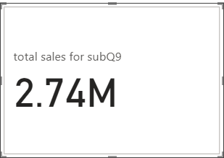

DAX :-

total sales for subQ9 = CALCULATE(SUMX(Orders,Orders[Unit Price]*Orders[Order Quantity]),Orders[Status]="Delivered",Orders[Product Category]="Fashion",Orders[Delivery Type]="Shipped from Abroad")

Other DAX functions used : AVERAGE,AVERAGEX,COUNTROWS,DIVIDE,SUMX,DISTINCTCOUNT,SAMPLEPERIODLASTYEAR etc

average_no_of_daays = ROUNDUP(CALCULATE(AVERAGEX(Orders,DATEDIFF(Orders[OrderDate],Orders[Delivery Date],DAY)),Orders[Status]="Delivered"),0)

count of reasons = CALCULATE(COUNTA(Orders[Reason]),Orders[Status]="Returned")

total count of products = DISTINCTCOUNT(Orders[Product])

Average_wait_time = AVERAGEX(Orders,DATEDIFF(Orders[OrderDate],Orders[Delivery Date],DAY))

Revenue_last_year = CALCULATE([Total_revenue_delivered],SAMEPERIODLASTYEAR(Calender_table[Date]))

- Wait Times Correlated with Demographics and Care: Explore how average wait times vary across different product categories to optimize scheduling and staffing.

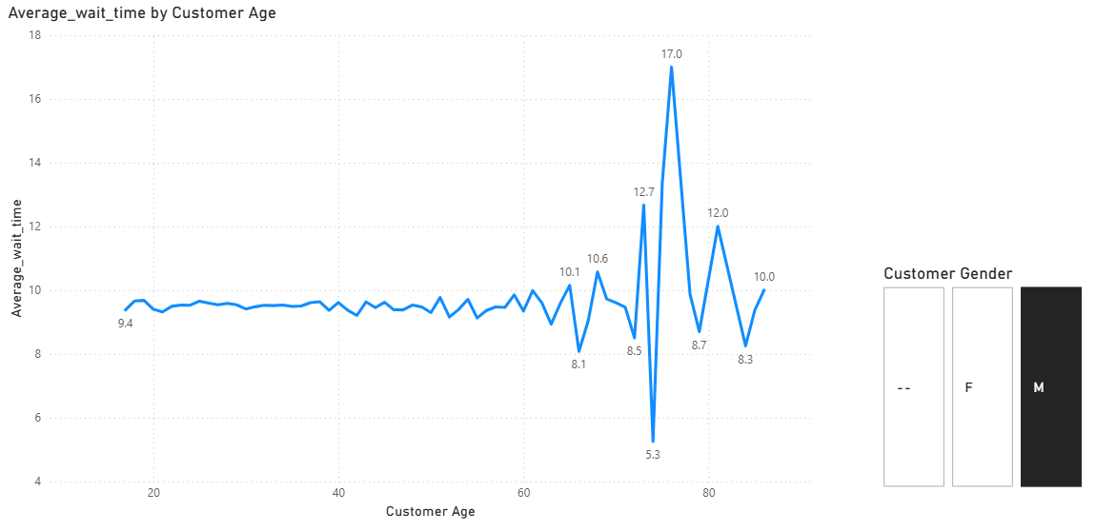
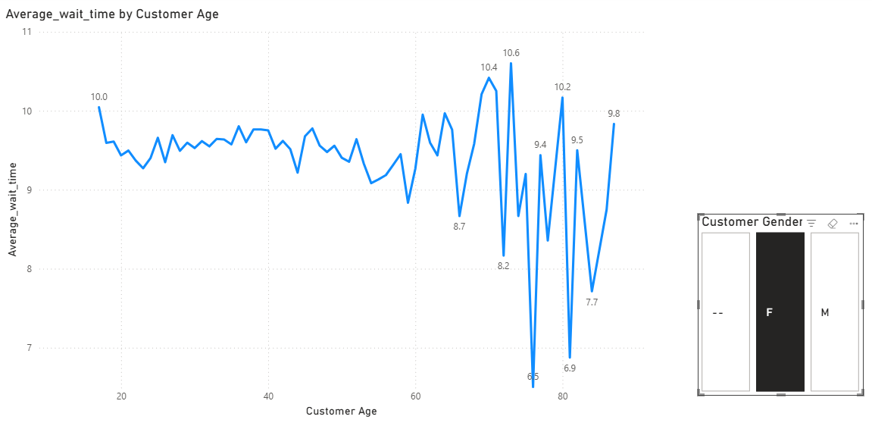

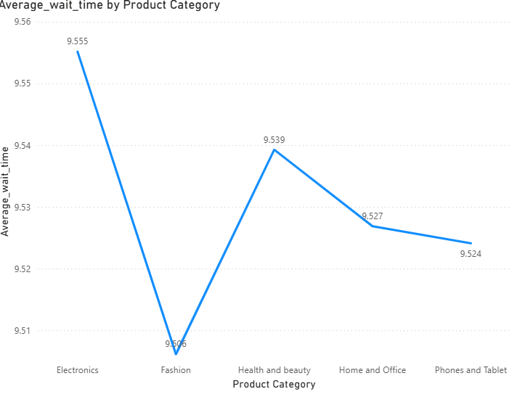

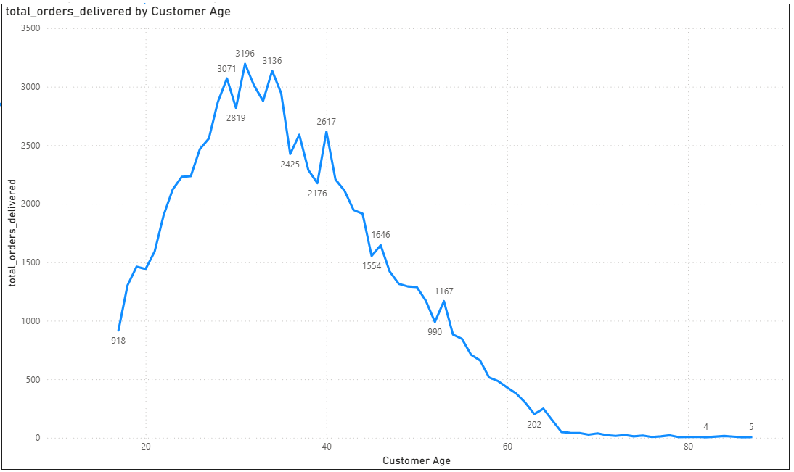

Interpretation and Suggesions :-
- For most age groups, average wait time hovers around 9–10 days.
- items may be shipped from central warehouses or abroad; longer courier routes; bulk packaging adds delays.
- Customers in age group 36–50 and 60+ experience the longest delays, likely due to ordering premium models that are not widely stocked.
- But there are spikes at older ages (60–80 years → up to 17 days).
- Gender split shows little difference → so age is a stronger factor than gender in determining wait times.
- Peak ordering comes from customers aged 25–40 (3,000+ orders).
- Orders decline steeply after age 50, but wait times for these older groups are longer (as seen in Images 1 & 2).
- This shows a double risk: older customers already order less, and when they do, their wait times are higher → this can discourage repeat orders further.
- Younger & middle-aged groups order the most and enjoy moderate wait times.
Especially in Fashion & Health and Beauty
- These show shorter average wait times (typically 5–7 days).
- As products are smaller, lighter, and often stocked locally; it may be easier for couriers to handle.
- Younger customers (18–25, 26–35) frequently purchase here, benefiting from faster shipping.

Suggestions:

- Stock high-demand models locally to cut delivery times.
- Prioritize these items for Express delivery expansion.
- Allocate extra warehouse and courier staff during peak months for these categories.
- Partner with specialized courier services for bulky items.
- Set clear ETAs and offer installation/assembly scheduling to improve satisfaction.
- Increase warehouse space for furniture/office essentials before peak demand periods.
- Maintain local stock to keep delivery times low.
- Use “Fast Delivery” badges as a marketing advantage.
- Ensure consistency — even a small delay in this category can cause low ratings given customer expectations for quick fashion/beauty delivery.

- Explore if there is any relationship between the Delivery type and waiting time between ordering and receiving an item.

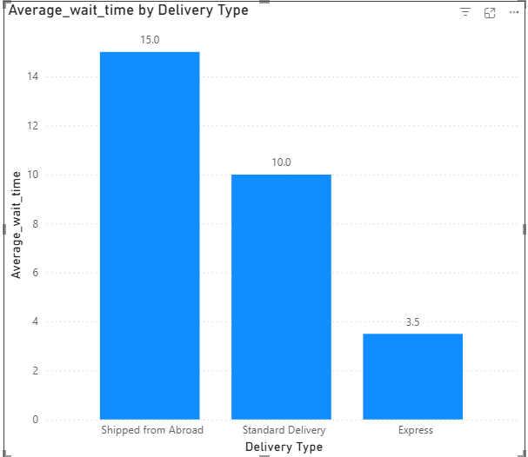

Express Delivery is fastest (3.5 days).
  - Shows efficiency of local supply chain + prioritization of shipments.
  - Stock is available in local warehouses, provides faster courier service, premium prioritization.
  - can be marketed as a premium Selling point : “Get it in 3 days with Express”
  - We must try to expand availability of Express to more product categories
Standard Delivery takes approx. 10 days.
  - It is acceptable for non-urgent items, but significantly slower than Express.
  - May discourage repeat purchases for customers expecting faster delivery.
  - Items may shipped domestically but from farther locations; logistics are not prioritized.
  - We must improve route optimization and better partnerships with local couriers.
  - Stocking items in multiple regional hubs, not just central warehouses might prove useful.
  - Offering pickup-point options for customers might be a way to assure customers of priority service .

Shipped from Abroad is the slowest (15 days).
  - Nearly 1.5x slower than Standard and 4x slower than Express.
  - Likely due to international shipping delays, customs clearance, and long-distance logistics.
  - There must be limited local stock, so products must be crossing borders.
  - Customs and import checks delay shipments.
  - Fewer flights/transport schedules.
  - We can build regional warehouses and pre-stock bestsellers locally.
  - We can also negotiate faster customs clearance with logistics partners.
  - We can also offer transparent ETAs to manage customer expectations
- Is there any relationship between shipping charges and product type?

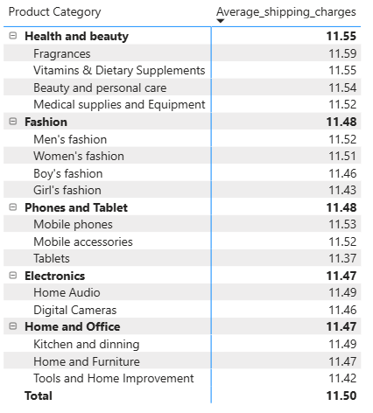
- Relationship is weak: Shipping charges are nearly identical across product types, with differences of less than 2%.
- Amazon probably likes flat shipping fee structure, ensuring customer simplicity and fairness.
- Customers are not penalized for choosing heavier items which is good for customer satisfaction but the company may be absorbing higher costs for bulky categories.
Recommendations:
- Keep a flat shipping policy for transparency and customer trust. But for cost-heavy items like Home & Office furniture, bulky appliances , explore tiered or weight-based shipping to get decent margins.
- Use free shipping promotions as a marketing strategy in Fashion and Electronics which are high-demand, high-margin categories.

- Come up with strategies to decrease the low rating orders after analyzing different factors like waiting time, shipping type, unit price, etc.

Waiting Time
- Longer wait times strongly correlate with low ratings, especially for Shipped from Abroad (15 days) and Standard Delivery (10 days) and many products were returned even after waiting for longer periods of time.
- Customers become dissatisfied if delivery takes much longer than expected and still not meeting expectations.
Strategies :
- Pre-stock bestsellers in regional/local warehouses to reduce delays.
- Provide accurate ETAs (Expected time of arrival) at checkout so expectations are realistic.
- Introduce loyalty points or small discounts for customers who accept longer delivery windows.
Shipping Type
Strategies:
- Expand Express Delivery to more categories/products.
- Improve local courier partnerships and route optimization for Standard Delivery.
- Highlight shipping type clearly at checkout so customers know the trade-off.
Unit Price
- Higher-priced products with quality issues get disproportionately harsher ratings.
- Customers expect premium items (e.g., Electronics, Fashion accessories) to be flawless.
Strategies:
  - Stricter quality control for premium-priced items.
  - Offering free extended warranty or protection plans for high-ticket products.
Product Category Patterns
- Fashion and Health & Beauty often face rating drops due to size/fit or personal expectations.
- Electronics/Phones get low ratings if defects or compatibility issues occur.
Strategies:
  - For Fashion we can add size charts, AR/fit tools, and easy exchange policies.
  - For Electronics we can emphasize compatibility, include detailed specs, and ensure proper packaging.
Low ratings have often come from expectation mismatch rather than actual product failure.

Strategies:
  - Enhance product descriptions with high-quality images, videos, and reviews.
  - Useing “Frequently Asked Questions” sections to address common concerns.
  - Flag items as “Shipped from Abroad” with longer timelines upfront.
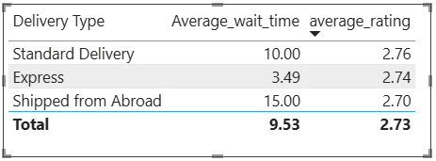
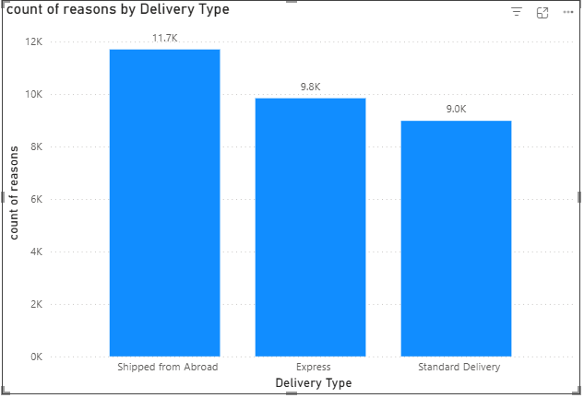
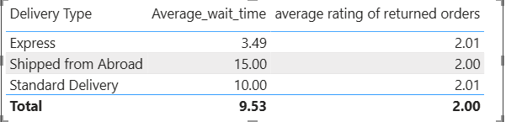

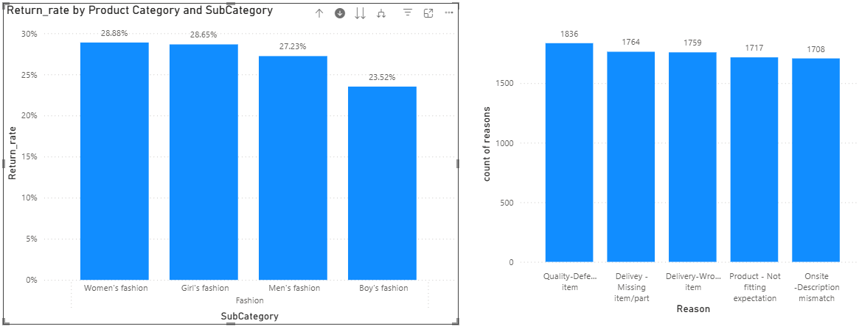

- Using the time intelligence DAX function, create a table to compare each month’s sales with the previous year’s same month’s total sales. So there will be four columns in the output year, month, total sales, previous_years_sales.
DAX functions used:-
Total_revenue_delivered = CALCULATE(SUM(Orders[Sale Price]),Orders[Status]="Delivered")

Total Revenue of LY month = CALCULATE([Total_revenue_delivered],SAMEPERIODLASTYEAR(Calender_table[Date]))

sub.14 %inc/dec = ROUNDDOWN(DIVIDE([Total_revenue_delivered]-[total Revenue of LY month],[total Revenue of LY month],BLANK())*100,2)

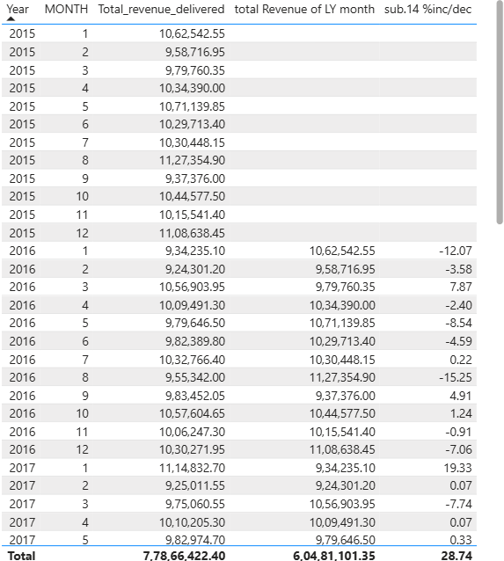
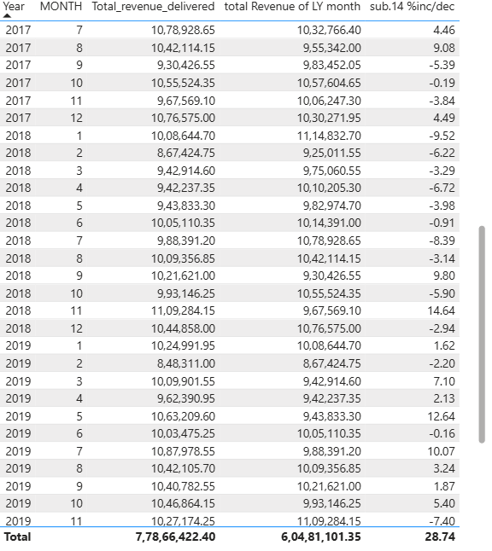

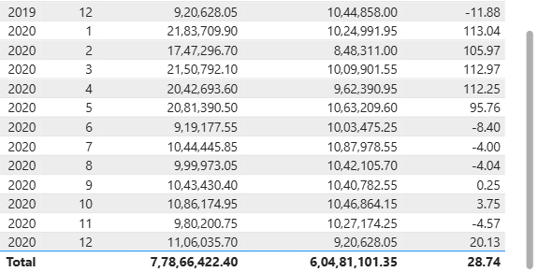

- What do you understand by PowerBI gateway? What are its use cases?

Suppose we have data in databases like SQL Server, Oracle DB, SAP, or Excel files in our PCs .This is called ON-Premises data . Now we want to update it to the power bi cloud for real time refresh.
There are 2 ways to do that . We can manually copy it and put it in cloud or we use an application called PowerBI Gateway.
Power BI Gateway solves this.
It’s a bridge that connects our private data sources with Power BI service securely.
So, instead of moving the entire database, Power BI just sends a request → Gateway fetches only what’s needed → sends it back securely to Power BI in the cloud.
Real-Life Use Cases
- Scheduled Refresh
  - Example: The sales data is stored in an on-prem SQL Server.
  - Every night at 2 AM, Gateway fetches the latest sales data and refreshes our cloud dashboard automatically.
- Direct Query
  - With Gateway, Power BI directly queries the on-prem database every time you open the dashboard → no lag, always current.
- Hybrid Organizations
  - A company has HR data on-prem (Oracle DB) and Marketing data in Azure SQL cloud.
  - With Gateway, you can combine both in a single Power BI report.
- Secure Access without Moving Data
  - Banks, healthcare, and government often cannot upload sensitive data to the cloud.
  - Gateway lets them keep data on-premises but still use Power BI Service dashboards.

- How would you approach this problem, if the objective and subjective questions weren't given?

I would first :
- Inspect the tables: Orders, Products, Customers, Categories, Locations, Returns.
- Identify key fields: Order Date, Revenue, Quantity, Product Category, Product Subcategory, Customer ID, Status ,Rating, Region.
- Clean & prepare: handle missing values, normalize product/category names.
- Track overall sales & revenue trends.
- Understand customer behavior & satisfaction through various measures like total sales, total orders, by age group and gender etc
- Identify top-selling and underperforming products.
- Measure returns, ratings, and loyalty impact.
- Revenue by category/subcategory/product.
- Units sold vs revenue (to catch high-volume, low-value vs low-volume, high-value products).
- Return rates by product.
Then use some visuals to understand patterns and then try to build a dashboard .

